Pre-Reading

How I found out
This paragraph starts off with the phrase 一开始 (yi4kai1shi3) as you know 一 means “one,” generally 开始 means “to start” but this phrase together means “from the beginning.” The second phrase that you will see is 没想到 (mei2xiang3dao4). The first thing to note in this phrase is the character 没. This is a negation word very similar to 不，however it is used in the past tense. For example, 我不去 means “I won’t go,” however if we change that to 我没去 it means “I didn’t go.” The second part of this phrase is 想 is comprised of top and bottom components. The top part is 相 it is the phonetic part it means mutual or exchange, the bottom part 心 (xin1) means “mind, heart, or soul.” Depending on the context 想can mean “want” or “think” here it means “think.” The 到 means “arrive” so I can say 我到了 meaning “I have arrived.” However in this expression the 到 represents the completion of an action or the arrival at the result of an action. So here 没想到can be translated as “not think of.” The next word is 那些 (na4xie1) which means “those.” 那 means that and is often seen with 那个 to mean “that one.” The 些 character gets its meaning from the bottom component 二 which means “two or a few.” You can also say 这些 which means “these.” 不过(bu4guo4) makes up the next word, the 不as you know means “no” and the 过 (guo4) means “to pass through” together they mean “however.” The following word is 知道 (zhi1dao), 道 means “path or method or principle”. 知means “to be aware” so this word means “the path to awareness” or “to know.” The following are five words that you’ll see in the house. The first is 客厅(ke4ting1) which means living room, the first character 客 refers to customers or guests and the second character 厅 is another name for a hall, so you could say 餐厅 which means dining hall. The second is 沙发(sha1fa1) which means sofa, both of these characters are phonetic characters the word sounds similar to sofa. The third is 卧室(wo4shi4) which means bedroom， the 卧 means to lie down or looking up and the 室 is and inside room, you can tell that its inside by the top of the character, that part is a roof radical. The next is 厨房(chu2fang2) which means kitchen, the word 厨 can combine with 厨师 to mean cooking master or chef. Finally, 厕所(ce4suo3) means bathroom or toilet. Are two prepositional phrases the first is 在。。里(li3). Which means inside of something, so 在城市里 means inside the city. The other phrase is 下面(xia4mian). The first character 下 means under as the character implies. The 面 character signifies face of something.” So, 下面 just means “under something.” Finally, you will see the word 看到(kan4dao) as you learned above 到means the result of an action, so here the action is to look for something or to see something, so 到 signifies that your eyes have reached a target.
Story Character Count = 79

Vocabulary/Writing
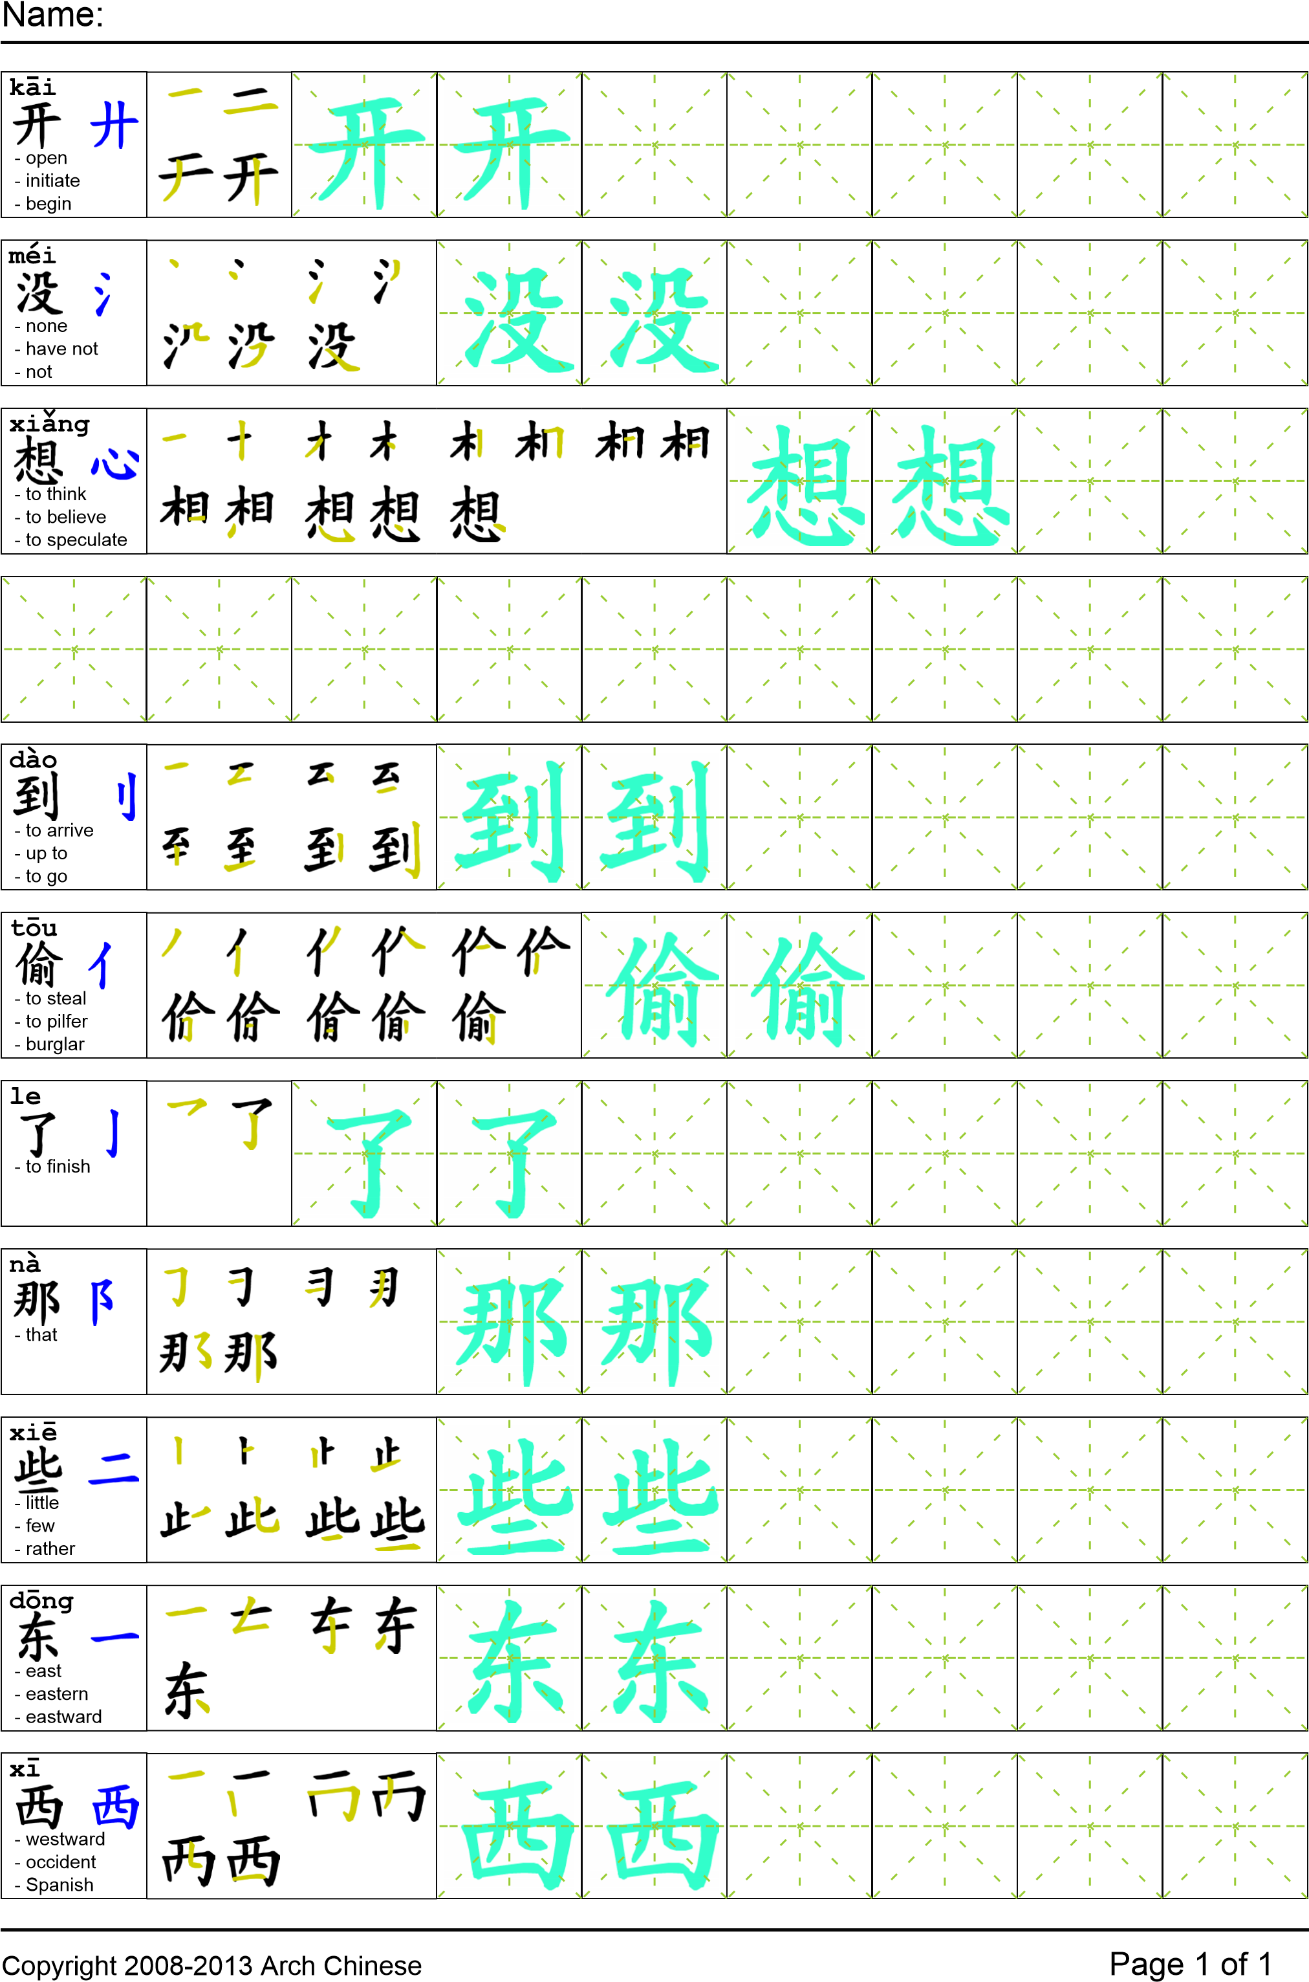
Reading

我一开始没想到是我爸爸偷了那些东西。不过我回家的时候就知道是他了。在客厅里的沙发下面我看到了白纸。在卧室里我看到了五个书包。在厨房我看到了很多的笔记本。在厕所我看到了书。

Task Completion

Once all tasks are complete turn the assignment in to collect the points for the project.
Task 1: Trace the vocabulary and copy the text into your notebook.

Task 2: Answer Comprehension Questions.

Task 3: Write the Pinyin for the Reading.

Task 4: Translate the Reading into English.

Task 5: Record yourself reading the passage.

Comprehension Questions
- What is structure used to say “under something?” _____________________________________
- What did the author find in the bedroom? ___________________________________________
- What phrase means “did not expect, or did not think of?”________________________________
- How did all of the objects arrive at the author’s house? _________________________________

